GAËLLE FRANKARD
SENIOR ATTORNEY
Partner
ABOUT ME
As a senior attorney specializing in employment law, I provide legal expertise to national and international companies across diverse sectors. I offer strategic advice on employment law cases with global or local impact from cross-border mergers and general employment law advisory work to collective dismissal/restructurings files including negotiations with representative and trade unions ensuring compliance with legal frameworks while aligning with business objectives.

My experience advising within globally recognized firms and working effectively with international teams has equipped me to adapt and thrive in ever-evolving environments.

SKILLS
Employment and social security law. Litigation. Legal interim management.
Excellent analytical and pragmatic approach, flexibility, communication skills, and teamwork capability.

PROFESSIONAL EXPERIENCE
2023 - present: Ethikos, Brussels
Partner – Employment

2021 -2023: Deloitte Legal, Brussels– Senior Managing Associate Lawyer in Employment, Pensions and Benefits Team

2015-2021: Reliance -Littler, Brussels – Counsel in Labour and Employment Law

2006-2015: Altius, Brussels - Employment law Associate

2003-2006- Lambrecht & Stiévenard / Lallemand & Legros , Brussels– Attorney-at-law

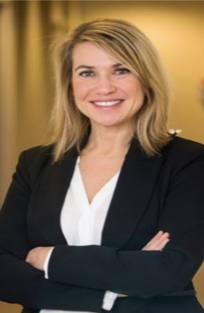

EDUCATION

2002: Brussels Bar since 2002 (Employment Law Specialist recognition by the Brussels Bar in 2013)
1999-2002: Master's degree in Law – Université Libre de Bruxelles (cum laude)
2001 : Erasmus Program (University of Amsterdam)
1997- 1999: Bachelor's degree in Law – Université Libre de Bruxelles

LANGUAGES
English: C1 - fully proficient
French: C2 - native
Dutch: B2 – professional working

CONTACT
Phone: +32 (0) 475 72 23 30
E-mail: g.frankard @ethikos.legal
Address: 66 Avenue Louise, 1050 Brussels
Date of birth: 14 July 1978

