**ALESSANDRO MERELLA**

**ATTORNEY**



**ABOUT ME**



Though naturally calm, I am an inherently dynamic extrovert who always keeps an open mind and remains honest and fair.

I enjoy carrying out responsibilities, highly value commitment, respect for professional ethics, and strive for a job well done.

I have a passion for cinema, a deep interest in social relationships, and enjoy reading and traveling. I am also open to any kind of new experience.

**SKILLS**

Regulatory, banking and financial law; Compliance, including AML; Private Equity; Commercial law.

Excellent communication and organizational skills, versatile, highly adaptable, with a creative and original approach to problem solving, and comfortable in any social situation.

**PROFESSIONAL EXPERIENCE**

**February 2021 - present: Secondments with Ethikos**

Long-term secondments (18 months to 4+ years) within major Belgian financial institutions active in (a.o.) the banking and private equity sectors: regulatory matters, governance, outsourcing, GDPR, general support, etc.

**December 2020 - present:**  **Ethikos, Brussels**

Attorney: extensive experience in regulatory watch and regulatory matters, legal opinions, contractual documents and procedural acts in various areas, including financial law, private equity, compliance (including AML) and commercial law.

**June 2017 - November 2017: La Boiserie SA (wood products), Waudrez**

Polyvalent employee: general and specialized salesman, in charge of the home supply department, cashier, in charge of orders and stock file management, customer adviser.

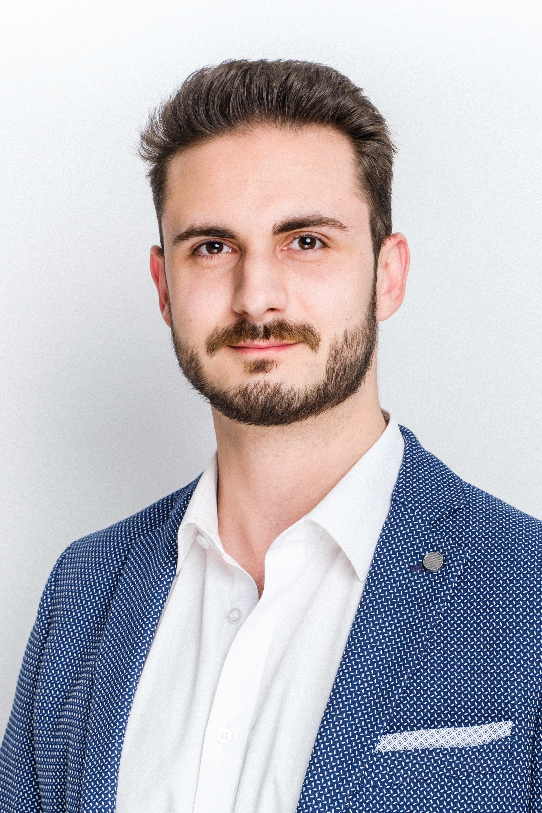

**February 2017 - March 2017**: **Anny Lhoir and Sophie Kebers - Associate notaries, Jemappes**

Executive secretary: direct intermediary, assistant, in charge of schedules, appointments, liaison and client reception.

**2009 - 2016:** **Pile ou Face (clothing store), Saint-Ghislain**

Commercial experience: unpacking, shelving, labeling, storage and sales, customer advises, stock files management.

**EDUCATION**

**2018 - 2020: Master's degree in Law** - economic and social law - ULB - Brussels, ***magna cum laude***

*Master's thesis: “Les apports en industrie sous l'empire du Code des sociétés et des associations : les conséquences de la réforme sur la société à responsabilité limitée (SRL)”.*

**2010 - 2018: Bachelor's degree in Law**

ULB - Mons.

**LANGUAGES**

**French**: C2 - native.

**English**: C1 - full professional proficiency.

**Italian**: C1 - professional proficiency.

**Dutch**: B1 - working proficiency.

**CONTACT**

Phone: +32 (0) 478.77.60.62

E-mail: [a.merella@ethikos.legal](mailto:a.merella@ethikos.legal)

Address: 66 Avenue Louise, 1050 Brussels

Date of birth: 25 December 1993