MEHDI RHALIB ALONSO
SENIOR ATTORNEY

ABOUT ME
Attorney registered at the Brussels Bar with a specialization in economic law and a strong interest in financial law, banking, and commercial law.
Passionate and enthusiastic about the law, each new case is an opportunity for me to deepen my knowledge by fully investing myself to pursue the objectives assigned.

SKILLS
Economic law and compliance, including AML, criminal and financial law.
Excellent communication skills, versatile. Imaginative, creative, and original approach to problem solving, my approach is always centered on client’s needs.

PROFESSIONAL EXPERIENCE
February 2021 - present: Ethikos, Brussels
Senior Attorney: compliance and AML policies, drafting of legal opinions, contractual documents and procedural acts in compliance, commercial and banking law.
November 2019 – February 2021: DBB DEFENSO, Brussels
Junior Attorney: gestion of legal opinions, requests, and procedural documents in civil and commercial law litigations. Drafting of legal opinions and legal documents in counseling contexts.

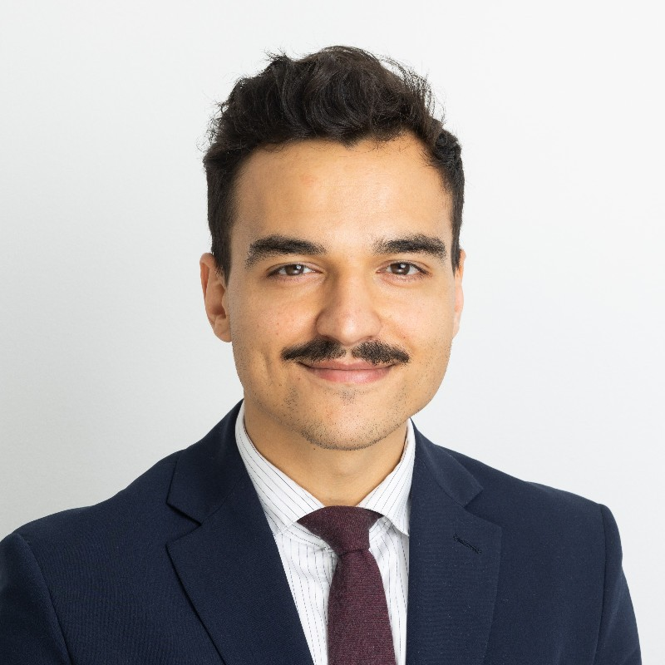

EDUCATION
2018 - 2019: Master of Laws – LLM – International and European Private Law – KU Leuven - Leuven, cum laude
2016 - 2018: Master’s degree – Social and Economic Law – ULB – Brussels, cum laude

2013 - 2016: Bachelor’s degree – Law – USLB – Brussels, cum fructu

LANGUAGES
French: C2 - mother tongue.
English: C1 - fully proficient.
Spanish: C1 - secondary mother tongue.
Dutch: B2 – upper intermediate.

CONTACT
Phone: +32 (0)477.196.123
E-mail: m.rhalib@ethikos.legal
Address: 66 Avenue Louise, 1050 Brussels
Date of birth: June 19th 1992

