THOMAS FAELLI
SENIOR ATTORNEY
Partner
ABOUT ME
I am a senior attorney, a regulatory, and compliance expert, a Certified Compliance Officer and a Certified Data Protection Officer.

Drawing on my extensive experience in the financial sector, I provide clients with pragmatic solutions to a wide range of regulatory and compliance issues.

I am a positive, conscientious, and outgoing person.
I was a stand-up comedian for five years; I have written two novels and love video games.

SKILLS
Banking and finance, Compliance, Data Protection, and Distribution.
Excellent communication skills, quality-oriented, versatile, highly adaptable, a creative problem-solver, caring and effective team manager.
PROFESSIONAL EXPERIENCE
2018 - present: Ethikos, Brussels
Co-founder and Partner – Banking & Compliance department

2017 - present: Lawyer in regulatory and compliance
Providing services to several (re)insurance companies, credit institutions and payment institutions.

February 2014 - February 2017: Legal counsel in regulatory and compliance at the FSMA (Belgian Financial Services and Markets Authority), Brussels

August 2012 – February 2014: Legal counsel at Belfius Bank, Brussels
September 2012 - June 2015: Professor of legal drafting at the Haute École Paul-Henri Spaak (Bachelor of Laws, 3rd year), Brussels

May 2008 – February 2012: Legal counsel at ARAG (legal protection insurance), Brussels

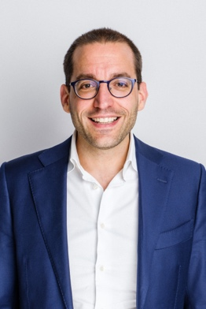

November 2003 – November 2007: Lawyer in renowned law firms: Lawfort (November 2003-October 2006) and Lydian (October 2006-November 2007)

EDUCATION

2024: Certified Compliance Officer – Assuralia/Insert

2022: CAMS (Certified Anti-Money Laundering Specialist) - ACAMS

2018: Certified Data Protection Officer - Maastricht University

2017: Certified Compliance Officer – Febelfin Academy

2016-2017: LL.M in corporate law – KUL

2006-2007: MBA - Solvay Business School

2002-2003: LL.M in advanced business law - Ghent University

1997-2002: Law degree – ULB

LANGUAGES
English: C1 – fully proficient
French: C2 - native
Dutch: C1 – fully proficient

CONTACT
Phone: +32 (0)496.24.37.48
E-mail: t.faelli@ethikos.legal
Address: 66 Avenue Louise, 1050 Brussels
Date of birth: 30 June 1979

